A connected graph is graph that is connected in the sense of a topological space, i.e., there is a path from any point to any other point in the graph. A graph that is not connected is said to be disconnected. This definition means that the null graph and singleton graph are considered connected, while empty graphs on.
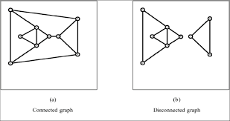
What is a tree?
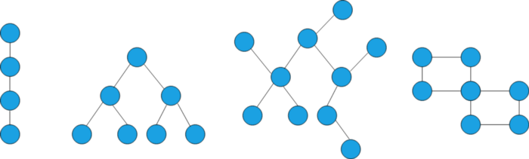
Photo by Author
We have a couple of graphs above, can you spot the odd one out?
Correct, the forth one stands out of the group. But why?
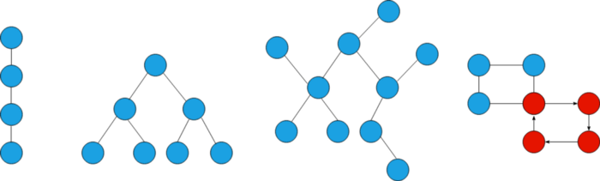
Photo by Author
Because a tree is an undirected graph with no cycles. The key thing to remember is trees aren’t allowed to have cycles in it. You could find one that broke the rule, right? Excellent job.
However, there’s another simple method which we can use to see whether the given graph is a tree or not. All trees have N - 1 edges, where N is the number of nodes.

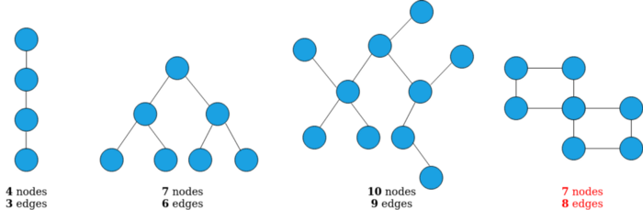

Three of our graphs meet the rule, right? But the last one doesn’t.

2. Spanning Tree
A spanning tree of an undirected graph G is a connected subgraph that covers all the graph nodes with the minimum possible number of edges. In general, a graph may have more than one spanning tree.
The following figure shows a graph with a spanning tree. The edges of the spanning tree are in red:
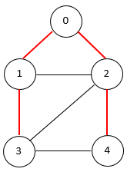

3. Minimum Spanning Tree
If the graph is edge-weighted, we can define the weight of a spanning tree as the sum of the weights of all its edges. A minimum spanning tree is a spanning tree whose weight is the smallest among all possible spanning trees.
The following figure shows a minimum spanning tree on an edge-weighted graph:
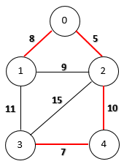

Storing Undirected Trees
We should start by assigning numbers to every node in the tree starting from 0 to n - 1, where n is the total number of nodes.
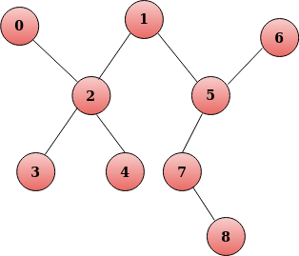

We could use an adjacency matrix to show whether there exists an edge between two nodes.
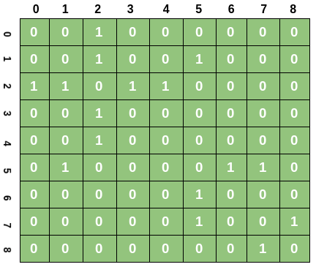
We fill the (i, j) cell of an adjacency matrix with 1 if there is an edge starting from node i to j, else 0. For example, if there is an edge exists in between nodes 5 and 7, then (5, 7) would be 1.
In practice, holding a tree as an adjacency matrix is cumbersome because most nodes may or may not have edges between them, so most of the cells would be sparse enough to hold memory for absolutely nothing.

Rooted Trees
Rooted trees would have a special node designated as a root node, thus the name rooted trees.
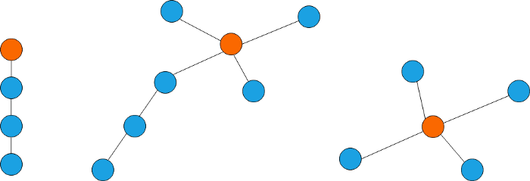
Here, nodes in orange color have been designated as roots. Either edges could be coming towards the roots or moving away from root. There would only be one root in every rooted trees. Some of the recursive algorithms use rooted trees under the hood to keep track of execution flow.

Binary Tree
We can never leave this session without mentioning the Binary Trees. We call them Binary Trees or simply B - Tree is because each and every node in the tree would have at most 2 child nodes in total.
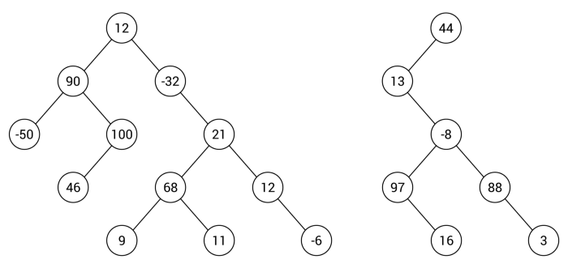

MORE ABOUT TREES

https://www.cs.sfu.ca/~ggbaker/zju/math/trees.html

Definition:-
A tree is a connected graph without cycles.
Properties of Trees
° A graph is a tree if and only if there is one and only one path joining any two of its vertices.
° A connected graph is a tree if and only if every one of its edges is a bridge.
° A connected graph is a tree if and only if it has N vertices and N; 1 edges.

Definitions:-
° A subgraph that spans (reaches out to ) all vertices of a graph is called a spanning subgraph.
° A subgraph that is a tree and that spans (reaches out to ) all vertices of the original graph is called a spanning tree.
° Among all the spanning trees of a weighted and connected graph, the one (possibly more) with the least total weight is called a minimum spanning tree (MST).

Kruskal's Algorithm
- Step 1
Find the cheapest edge in the graph (if there is more than one, pick one at random). Mark it with any given colour, say red.
- Step 2
Find the cheapest unmarked (uncoloured) edge in the graph that doesn't close a coloured or red circuit. Mark this edge red.
- Step 3
Repeat Step 2 until you reach out to every vertex of the graph (or you have N ; 1 coloured edges, where N is the number of Vertices.) The red edges form the desired minimum spanning tree.
  - Kruskal Step by Step
  - Tutorial Kruskal
  - Interactive Kruskal's Algorithm

Dijkstra's algorithm allows us to find the shortest path between any two vertices of a graph. It differs from the minimum spanning tree because the shortest distance between two vertices might not include all the vertices of the graph.

Strictly, the answer is no. Dijkstra's algorithm finds the shortest path between 2 vertices on a graph. However, a very small change to the algorithm produces another algorithm which does efficiently produce an MST.
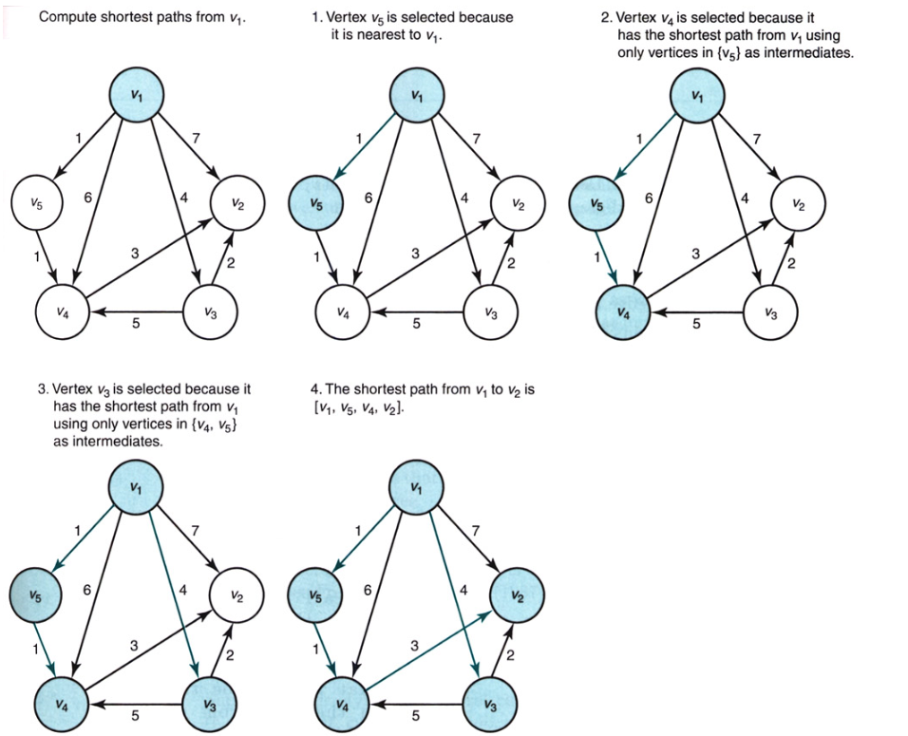

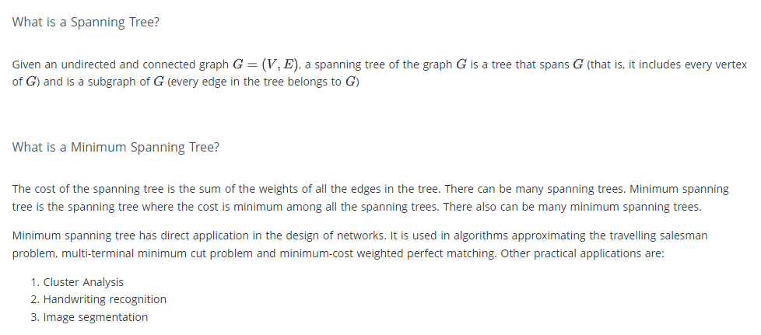

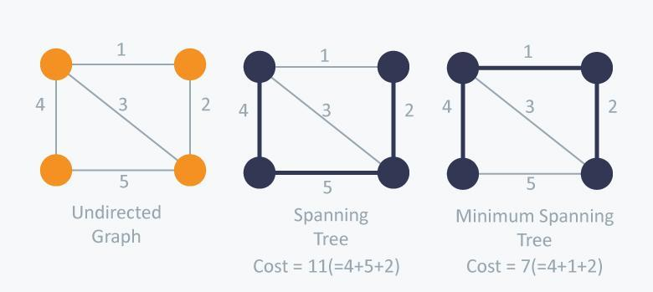

There are two famous algorithms for finding the Minimum Spanning Tree:

Kruskal’s Algorithm
Kruskal’s Algorithm builds the spanning tree by adding edges one by one into a growing spanning tree. Kruskal's algorithm follows greedy approach as in each iteration it finds an edge which has least weight and add it to the growing spanning tree.

Algorithm Steps:
- Sort the graph edges with respect to their weights.
- Start adding edges to the MST from the edge with the smallest weight until the edge of the largest weight.
- Only add edges which doesn't form a cycle , edges which connect only disconnected components.
So now the question is how to check if 2 vertices are connected or not ?
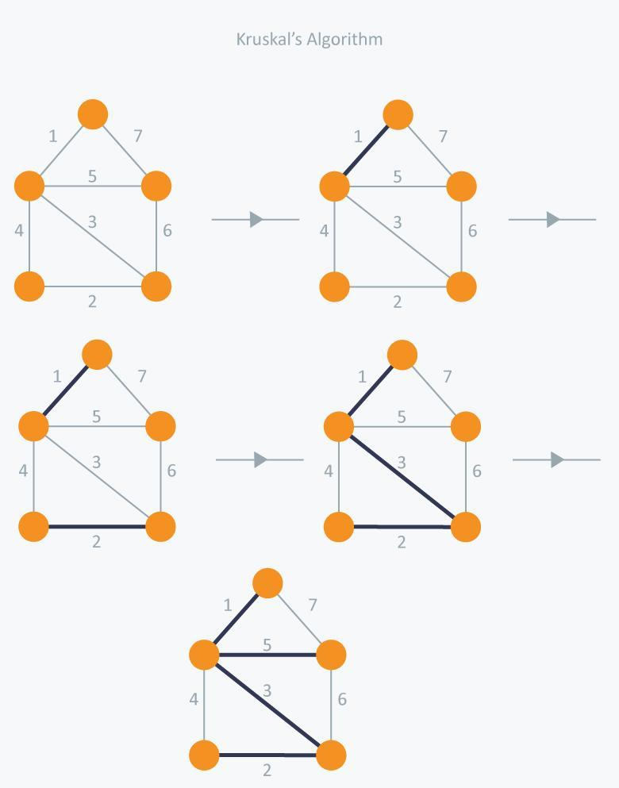

In Kruskal’s algorithm, at each iteration we will select the edge with the lowest weight. So, we will start with the lowest weighted edge first i.e., the edges with weight 1. After that we will select the second lowest weighted edge i.e., edge with weight 2. Notice these two edges are totally disjoint. Now, the next edge will be the third lowest weighted edge i.e., edge with weight 3, which connects the two disjoint pieces of the graph. Now, we are not allowed to pick the edge with weight 4, that will create a cycle and we can’t have any cycles. So we will select the fifth lowest weighted edge i.e., edge with weight 5. Now the other two edges will create cycles so we will ignore them. In the end, we end up with a minimum spanning tree with total cost 11 ( = 1 + 2 + 3 + 5).

Time Complexity:
In Kruskal’s algorithm, most time consuming operation is sorting because the total complexity of the Disjoint-Set operations will be O(ElogV), which is the overall Time Complexity of the algorithm.
Prim’s Algorithm
Prim’s Algorithm also use Greedy approach to find the minimum spanning tree. In Prim’s Algorithm we grow the spanning tree from a starting position. Unlike an edge in Kruskal's, we add vertex to the growing spanning tree in Prim's.
Algorithm Steps:
- Maintain two disjoint sets of vertices. One containing vertices that are in the growing spanning tree and other that are not in the growing spanning tree.
- Select the cheapest vertex that is connected to the growing spanning tree and is not in the growing spanning tree and add it into the growing spanning tree. This can be done using Priority Queues. Insert the vertices, that are connected to growing spanning tree, into the Priority Queue.
- Check for cycles. To do that, mark the nodes which have been already selected and insert only those nodes in the Priority Queue that are not marked.
Consider the example below:
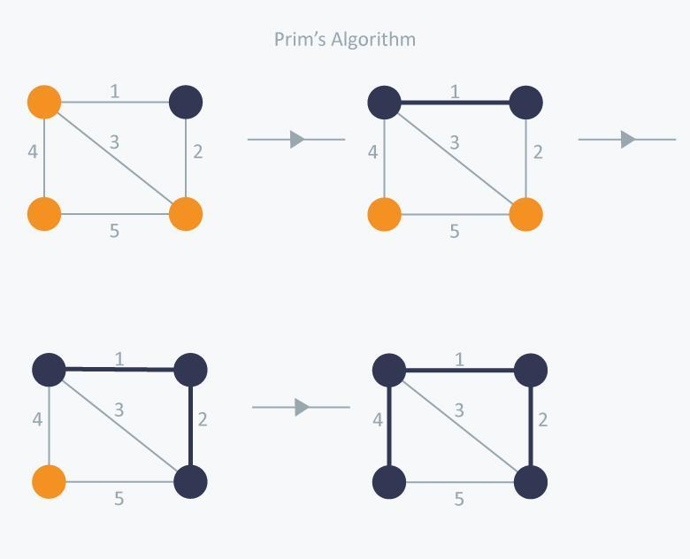

In Prim’s Algorithm, we will start with an arbitrary node (it doesn’t matter which one) and mark it. In each iteration we will mark a new vertex that is adjacent to the one that we have already marked. As a greedy algorithm, Prim’s algorithm will select the cheapest edge and mark the vertex. So we will simply choose the edge with weight 1. In the next iteration we have three options, edges with weight 2, 3 and 4. So, we will select the edge with weight 2 and mark the vertex. Now again we have three options, edges with weight 3, 4 and 5. But we can’t choose edge with weight 3 as it is creating a cycle. So we will select the edge with weight 4 and we end up with the minimum spanning tree of total cost 7 ( = 1 + 2 +4).

